**Cloud Security**

IS 550-01 Cybersecurity Management

By

Amogh Patel

July 25, 2023

**I. Introduction**

**A. Background on cloud computing**

Cloud computing is a paradigm that allows users to access and utilize a shared pool of computing resources over the internet. It involves the delivery of on-demand computing services, including servers, storage, databases, networking, software, and analytics, without the need for users to have their own physical infrastructure or hardware. ‘*In 1997, Professor Ramnath Chellapa of Emory University defined cloud computing as the new “computing paradigm, where the boundaries of computing will be determined by economic rationale, rather than technical limits alone”’.[1]*

**B. Significance of cloud security**

Cloud security is of utmost significance as it ensures the protection and confidentiality of sensitive data stored in the cloud, prevents unauthorized access and data breaches, meets regulatory compliance requirements, mitigates security threats, enables business continuity and disaster recovery, and instills trust in cloud services by providing robust security measures that address shared responsibility between cloud providers and customers, ultimately safeguarding the integrity and availability of cloud-based systems and data.

**II. Overview of Cloud Security**

**A. Definition and importance of confidentiality, integrity, and availability**

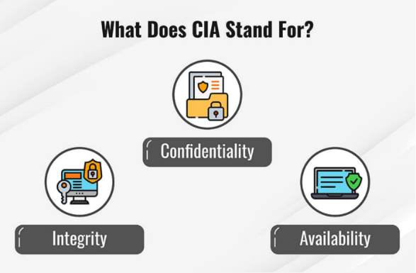

*What does CIA stand for [2]*

**Confidentiality:** Maintaining confidentiality within an organization involves ensuring the secrecy and privacy of data. This requires controlling access to information to prevent unauthorized sharing, whether it is intentional or accidental. The primary goal is to prevent people without proper authorization from accessing critical business assets, while also ensuring that those who need access have the appropriate privileges. An effective confidentiality system achieves this balance of access control. *‘To fight against confidentiality breaches, you can classify and label restricted data, enable access control policies, encrypt data, and use multi-factor authentication (MFA) systems. It is also advisable to ensure that all in the organization have the training and knowledge they need to recognize the dangers and avoid them.’ [2]*

**Integrity:** *‘Compromising integrity is often done intentionally.’ [2].*Integrity refers to the assurance that your data is reliable, trustworthy, and has not been tampered with. Data integrity is upheld when the information is genuine, precise, and dependable, leaving no room for doubt about its accuracy or authenticity. *‘A method for verifying integrity is non-repudiation, which refers to when something cannot be repudiated or denied. For example, if employees in your company use digital signatures when sending emails, the fact that the email came from them cannot be denied. Also, the recipient cannot deny that they received the email from the sender.’ [2].*

**Availability:** Ensuring data confidentiality and integrity alone is insufficient; the data's value lies in its accessibility to both employees within the organization and the customers they serve. This necessitates the proper functioning and timely availability of systems, networks, and applications. Additionally, authorized individuals should be able to access the required information promptly and without undue delays, ensuring that data retrieval does not become a cumbersome process. *Organizations can ensure availability by redundancy of networks, servers, and applications. [2].*

**B. Challenges in maintaining security in cloud environments.**

The primary point is that cloud security is a joint effort. It is crucial to have a comprehensive understanding of the division of security tasks between the cloud provider and the organization. This clarity ensures that each party knows their specific responsibilities in maintaining a secure cloud environment. The level of responsibilities differs based on where the workload is hosted whether it's on Software-as-a-Service (SaaS), Platform-as-a-Service (PaaS), Infrastructure-as-a-Service (IaaS), or within an on-premises datacenter.

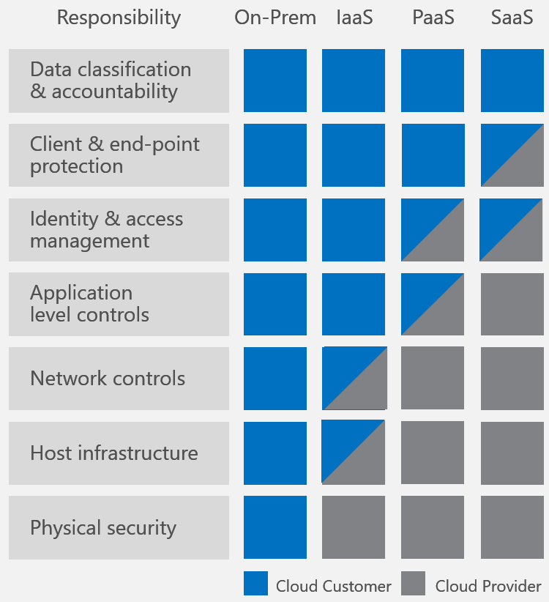

Cloud services and their security responsibilities. [5]

*‘Cloud computing does not mean a reduction on the overall security scope, and it does require customers to manage some of the stack in a shared18 responsibility model.’* [4].

**IV. Recommendations and Best Practices**

**Risk Assessment:** Assess the unique security vulnerabilities and regulatory requirements relevant to our organization. Identify any potential shortcomings and create a tailored risk management system to effectively tackle these challenges.

**Access Control:** Implement rigorous access controls through multi-factor authentication, role-based access controls (RBAC), and regular access evaluations. By restricting access privileges to authorized individuals only, the likelihood of unauthorized access is significantly reduced.

**Regular Updates and Patches:** Ensure the ongoing security of your cloud infrastructure and applications by consistently applying the latest security patches. Regularly updating software will address potential vulnerabilities and guard against emerging threats effectively.

**Monitor and Detect Anomalies:** Establish strong monitoring and detection systems to promptly identify any suspicious activities or potential security breaches. Utilize state-of-the-art security tools and technologies to proactively detect and address threats, ensuring a swift and effective response.

**Conducting Regular Audits and Assessments:** Conduct regular audits and assessments to assess your cloud security and compliance status. This practice ensures alignment with industry standards and regulations, minimizing potential risks and vulnerabilities.

**V. Conclusion**

In conclusion, cloud security is a critical aspect of modern computing that requires careful consideration and proactive measures. The adoption of cloud computing offers numerous benefits, such as scalability, cost efficiency, and accessibility, but it also introduces unique security challenges. To maintain confidentiality, integrity, and availability (CIA) principles in cloud environments, organizations must embrace a shared responsibility model with their cloud providers. Understanding the division of security tasks between the organization and the cloud provider is essential to ensure a strong security posture.

Cloud security requires a multi-layered approach that includes robust encryption, access controls, regular audits, continuous monitoring, and proactive threat detection and response. Additionally, addressing insider threats and ensuring compliance with industry regulations are crucial components of a comprehensive cloud security strategy.

As cloud technology continues to evolve, so do the security threats and best practices. Organizations must stay vigilant, regularly update their security measures, and foster a culture of security awareness among their employees. By prioritizing cloud security and taking collective responsibility, organizations can confidently leverage the potential of cloud computing while safeguarding their sensitive data and maintaining the trust of their customers and stakeholders.

**Citation:**

1. Keith D. Foote (2021, December 17). *A Brief History of Cloud Computing.* Retrieved July 17, 2023, from https://www.dataversity.net/brief-history-cloud-computing/
2. Fortinet (2023). *CIA Triad.* Retrieved July 17, 2023.https://www.fortinet.com/resources/cyberglossary/cia-triad#:~:text=The%20three%20letters%20in%20%22CIA,and%20methods%20for%20creating%20solutions*.*
3. David Mitchell Smith (Gartner, 2017). *Cloud Strategy Leadership.* Retrieved July 18, 2023. https://www.gartner.com/imagesrv/books/cloud/cloud_strategy_leadership.pdf
4. Julia YuZhou Chen. *Challenges Around Information Security Management in the Public Cloud – Using Managed Security Service Providers in Multi-Cloud Environment.* Master’s thesis, Informatics: Programming and System Architecture Information Security, University of Oslo, 2021. https://www.duo.uio.no/bitstream/handle/10852/87131/MasterThesis_juliayc.pdf?sequence=5&isAllowed=y
5. Diana Kelleys (2018). *Driving data security is a shared responsibility, here’s how you can protect yourself.* Retrieved (July 18, 2023). https://www.microsoft.com/security/blog/2018/06/19/driving-datasecurity-is-a-shared-responsibility-heres-how-you-can-protect-yourself,